Image 1: Bird’s Eye View
This image provides context to premises orientation and information about nearby premises and risk areas such as bodies of water, poultry premises, feed mills, etc. Include three parcels out from your premises, identify major cross roads, topography of the area, relevant premises or potential risk areas.

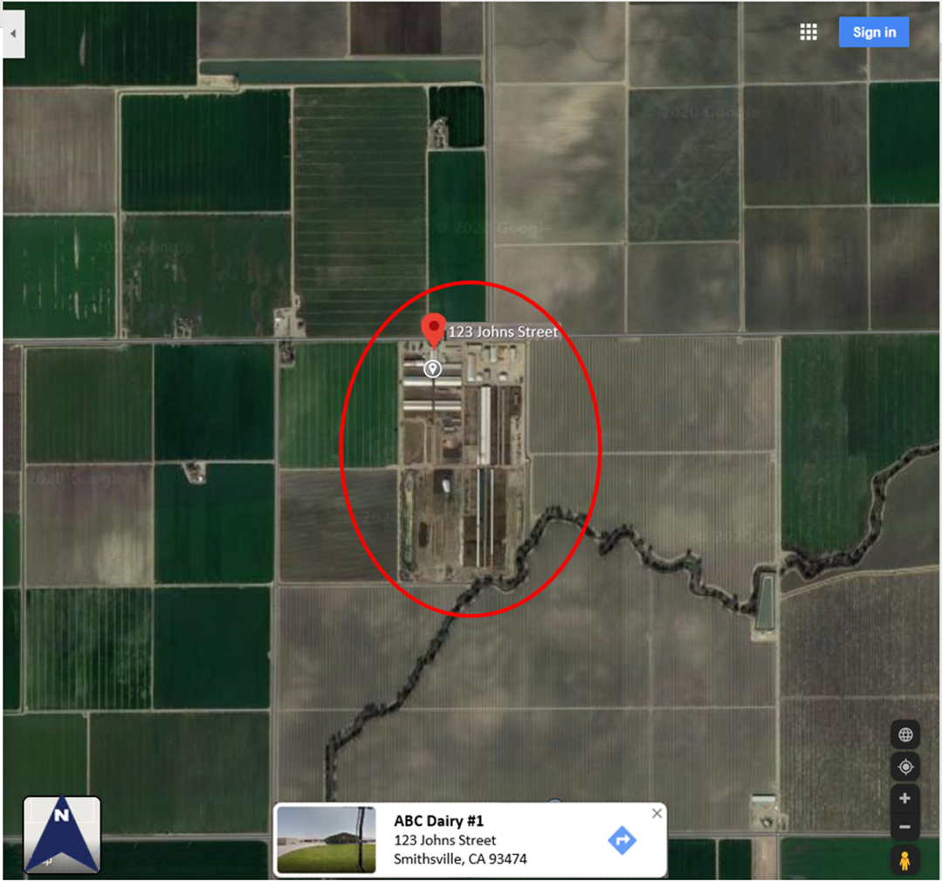
Image 2: Premises Structures
This image allows identification all of the structures on the premises.

1 | [Example: Offices] | 11 | [Example: Dry lots]
2 | [Example: Milking Parlor] | 12 | [Example: Lagoon/ manure compost]
3 | [Example: Free Stall #1] | 13 | [Example: Settling Basins]
4 | [Example: Free Stall #2] | 14 | [Example: Lagoon]
5 | [Example: Free Stall #3] | 15 | [Example: Employee and Visitor Parking]
6 | [Example: Free Stall #4] | 16 | [xxxxx]
7 | [Example: Free Stall #5] | 17 | [xxxxx]
8 | [Example: Commodity Barns / Silage] | 18 | [xxxxx]
9 | [Example: Dry lots] | 19 | [xxxxx]
10 | [Example: Dry lots] | 20 | [xxxxx]
Image 3: SFS Biosecurity Measures
This image illustrates the layout of premises and detailed information about the biosecurity measures. Please include items listed in the legend to identify activity on your premises.

 | Compass |  | Non-essential  Pick-ups/Deliveries
 | PBA Outer Boundary |  | Employee/Visitor Parking
 | Perimeter Access Points |  | Propane Tank
 | Locked Gates or Doors |  | Manure Pile
 | Vehicle C&D stations |  | Public Road
 | Full PPE Stations |  | Foot Traffic
 | Hand Sanitizing |  | Manure Hauler Traffic
 | Foot Bath Stations |  | Feed Delivery Traffic
 | Deadstock pile |  | Milk Pick Up Delivery Traffic
 | Garbage Barrel or Dumpster |  | Rendering Traffic

Note: Use the icons that indicate your biosecurity and managements practices. Some icons may not apply to your operation.

